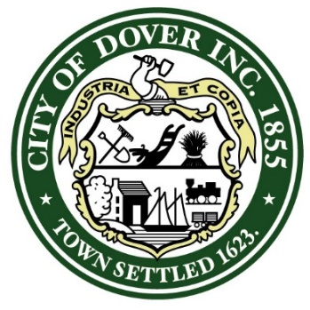

PROCLAMATION

WHEREAS: It is with great pride and admiration that we recognize the outstanding achievements and dedicated service of Commander Lane, a native of Huffman, Texas, in the United States Navy; and
WHEREAS: Commander Lane’s unwavering commitment, exceptional leadership, and remarkable accomplishments have brought honor not only to himself but also to the City of Dover, New Hampshire; and
WHEREAS: We acknowledge Commander Lane’s remarkable career in the United States Navy, which began in 1992 when he enlisted, and his subsequent commissioning in 2001 through the Naval Reserve Officer Corps at the University of Houston, where he graduated Magna Cum Laude with a Bachelor of Science degree in Electrical Technology; and
WHEREAS: Commander Lane has served with distinction at sea, undertaking various sea duty assignments onboard the USS CARL VINSON, USS JEFFERSON CITY, USS MARYLAND, and USS LA JOLLA; and
WHEREAS: Commander Lane assumed command of USS GREENEVILLE in 2020, overseeing a change in homeport and a successful Engineered Overhaul; and
WHEREAS: Commander Lane’s dedication and commitment have earned him numerous accolades, including the Meritorious Service Medal, Navy Commendation Medal, Navy Achievement Medal, and various unit and campaign awards; and
WHEREAS: Commander Lane, together with his wife, Carrie, have chosen to retire in the City of Portsmouth, New Hampshire, and make it their home.

NOW, THEREFORE, I, ROBERT CARRIER, MAYOR FOR THE CITY OF DOVER, NEW HAMPSHIRE, DO HEREBY PROCLAIM AND RECOGNIZE COMMANDER LANE FOR HIS EXCEPTIONAL SERVICE, UNWAVERING DEDICATION, AND REMARKABLE ACHIEVEMENTS IN THE UNITED STATES NAVY. WE EXTEND OUR HEARTFELT GRATITUDE FOR HIS SERVICE.
IN WITNESS WHEREOF, I have here unto set my hand and caused the Seal of the City of Dover to be affixed this 24th Day of May, 2023.

_______________________________
Robert Carrier, Mayor,
City of Dover, New Hampshire

