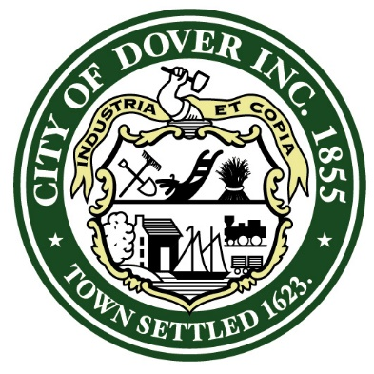
PROCLAMATION

WHEREAS: Great Bay Rowing, the esteemed rowing club of the Seacoast region, has achieved remarkable success in the field of competitive rowing; and

WHEREAS: Great Bay Rowing has demonstrated unparalleled dedication and commitment, resulting in the qualification of ten outstanding athletes to compete at the highly esteemed USRowing Youth National Championship Regatta in Sarasota, Florida, from June 8th to June 11th, 2023; and

WHEREAS: These exceptional athletes have earned their place in the national championship by securing top finishes in the Grand Final at the Northeast Regional Youth Championships, with their commendable performances leading to silver medals for the women’s quadruple sculls and women’s U17 single scull, as well as a bronze medal for the men’s U17 double sculls; and

WHEREAS: The qualifications of these ten athletes to the USRowing Youth National Championship Regatta showcases their unwavering dedication, teamwork, and the record-breaking accomplishments of Great Bay Rowing since its establishment in 1997; and

WHEREAS: The participation of these athletes in the national championship reflects positively on the City of Dover and serves as an inspiration to the entire community. and

Now, therefore, I, Robert Carrier, Mayor of the City of Dover, New Hampshire, do hereby proclaim that the City of Dover proudly recognizes and celebrates the remarkable achievements of Great Bay Rowing and their ten athletes who has qualified to compete at the USRowing Youth National Championship Regatta. We commend their exemplary dedication, hard work, and exceptional performance, which have elevated the reputation of Great Bay Rowing and brought honor to our community.

We extend our sincerest congratulations to the following athletes from Great Bay Rowing:

Ava Cathey, Katherine McEwan, Katie Braddick, Belle Greenshields, Jack Diamonti, Brogan Fernald, Colin Caron, Oliver Johnson, Eric Berg, and Griffin Oake-Libow.

May these exceptional athletes continue to inspire and serve as role models for future generations, reminding us all of the power of perseverance, teamwork, and dedication. We wish them the very best in their pursuit of excellence at the USRowing Youth National Championship Regatta.

IN WITNESS WHEREOF, I have here unto set my hand and caused the Seal of the City of Dover to be affixed this 14th Day of June, 2023

______________________________________________
Robert Carrier, Mayor,
City of Dover, New Hampshire

