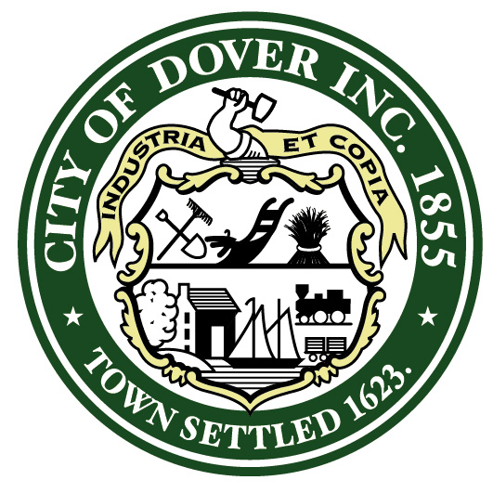

P R O C L A M A T I O N
WHEREAS: It is with great honor and admiration that we recognize Suzanne Weete, Co-Founder of the Dover Mental Health Alliance (DMHA), suicide prevention trainer, and adult/youth/teen mental health first aid instructor, for her distinguished public service and outstanding contributions for the benefit of children; and

WHEREAS: Suzanne Weete has demonstrated exceptional leadership and dedication to the promotion of mental health awareness and support in the Dover community and schools, making a significant impact on the Dover School District and community; and

WHEREAS: as the Community Engagement and Education Manager at Community Partners, Suzanne has been instrumental in the formation and success of the DMHA, which serves as a model for other communities in addressing the pressing issue of mental health; and

WHEREAS: Suzanne’s tireless efforts have brought the importance of mental health to the forefront, creating a movement that continues to gain momentum and making a difference in the lives of children and adults in our community; and

WHEREAS: Suzanne has secured a five-year Substance and Mental Health Service Administration Federal Grant, providing mental health education to faculty and staff in surrounding school districts and further expanding the reach of her impactful work; and

WHEREAS: Suzanne has trained hundreds of community members in Mental Health First Aid and NAMI Connect Suicide Prevention, empowering individuals with the knowledge and skills to support those in need; and

WHEREAS: Suzanne has supported the Dover High School Mental Health Initiative and facilitated its expansion to the Middle School, ensuring that mental health education and support reaches students at crucial stages of their development; and

WHEREAS: Suzanne’s leadership, dedication, and unwavering commitment to promoting mental health and support have made her a true inspiration to others, embodying the spirit of the NHSAA Champions of Children Award; and

WHEREAS: Suzanne Weete was recognized by the New Hampshire School Administrators Association for receiving the 2023 NHSAA Champions for Children Award.

NOW, THEREFORE, I, Robert Carrier, Mayor for the City of Dover, do hereby acknowledge Suzanne Weete’s exceptional contributions and her ongoing dedication to fostering mental health awareness, eliminating stigma, and creating a supportive community for children and their families.

BE IT FURTHER PROCLAIMED, that Suzanne Weete is commended for her outstanding public service and recognized as an exemplary role model for her unwavering commitment to the well-being of children in our community.

IN WITNESS WHEREOF, I have here unto set my hand and caused the Seal of the City of Dover to be affixed this 14th day of June, 2023.

Robert Carrier, Mayor

