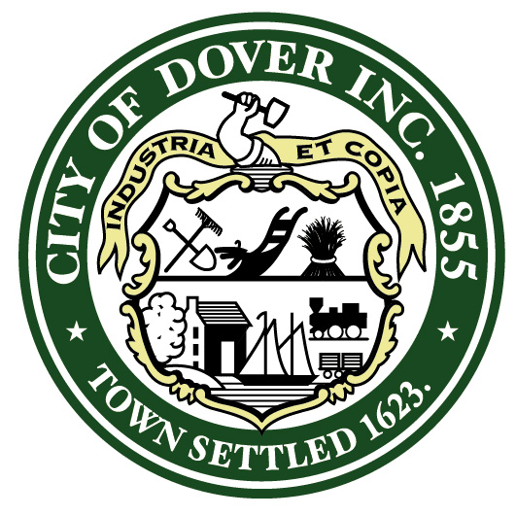

P R O C L A M A T I O N
WHEREAS: Frank Torr has dedicated over 40 years to real estate development and community development in Dover, demonstrating an unwavering commitment to the City; and

WHEREAS: Frank Torr’s extensive involvement in public service includes his notable positions on the Dover City Council and as a representative for Dover in the State Senate; and

WHEREAS: Frank Torr consistently strives to foster a positive forward-thinking community in Dover, continuously seeking ways to enhance the City’s development and evolution; and

WHEREAS: Frank Torr served as a valuable member of the Cochecho Waterfront Development Advisory Committee from 2005 to 2015, contributing his expertise to its endeavors; and

WHEREAS: Frank Torr’s dedication extended to serving on the boards of the Pease Development Authority and Sky Haven Air Port, actively participating in their activities; and

WHEREAS: Frank Torr has been an indispensable member of the Dover Planning Board since March of 1998, where he held the position of vice chair for four years and chair for a year, providing exceptional leadership; and

WHEREAS: Frank Torr diligently represented the Board as a member of the Technical Review Committee for a decade, showcasing his commitment to thoroughness and expertise; and

WHEREAS: Frank Torr’s contributions are marked by his wealth and breadth of experience, exemplifying thoughtfulness, fairness, and a remarkable ability to articulate well-reasoned and pertinent insights; his infectious smile and positive attitude serve as a beacon of inspiration to fellow volunteers; and

WHEREAS: Frank Torr’s tireless efforts have consistently aimed to protect property rights, promote responsible growth, and set an exemplary standard for professional conduct, courtesy, and respect; and

WHEREAS: The New Hampshire Planners Association, recognizing Frank’s outstanding contributions to Dover and Statewide Planning efforts, honored him with the Citizen Planner of the Year for 2020.

NOW, THEREFORE, the Mayor, City Council, and all citizens of Dover express their heartfelt gratitude to FRANK TORR for his unwavering dedication to excellence and exceptional service to the community, and extend their best wishes to him in all his future endeavors.
IN WITNESS WHEREOF, I have here unto set my hand and caused the Seal of the City of Dover to be affixed this 14th day of June, 2023.

Robert Carrier, Mayor

