Resolution 2005.02.09 12B-15 Resolution Re Delegation of Waterfront

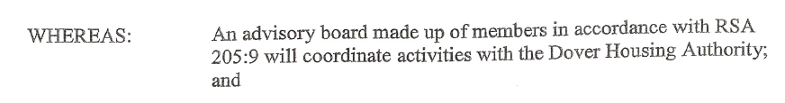
RSA 205:9

205:9 Advisory Board. – For the purpose of coordinating its activities and undertakings under this chapter with the needs and undertakings of other local organizations and groups, a housing authority may establish an advisory board consisting of the chairman of the authority (who shall be chairman of the advisory board) and of sufficient members to represent so far as practicable: the general public and consumers of housing; general business interests; real estate, building and home financing interests; labor; any official planning body in the locality; and church and welfare groups. The members of the advisory board shall be appointed by the chairman of the authority.

C3-11. Powers and Duties.

The City Council shall be the governing body of the City of Dover, shall set policies for city government and shall bear full responsibility for the implementation of said policies through the hiring and supervision of the City Manager. [Added 11-05-2005 by Municipal Election]

Except as herein otherwise provided, the City Council shall have all the powers and discharge all the duties conferred or imposed upon city councils, boards of mayor and aldermen and selectmen of towns by law. Except as otherwise provided in this Charter, all boards, commissions and committees shall be appointed by the Council.

C5-5. Powers and Duties of Manager.

The Manager shall supervise and be responsible for the administrative affairs of the city and shall carry out the policies enacted by the Council. He/she shall be charted with the preservation of the public peace and health and safety of persons and property and shall see to the enforcement of the ordinances of the city, this Charter and the laws of the state. He/she shall keep the Council informed of the condition and needs of the city and shall make such reports and recommendations as he/she may deem advisable or may be requested by the Council and perform such other duties as may be prescribed by this Charter or required of him/her by ordinance or resolution of the Council, not inconsistent with this Charter. He/she shall have and perform such other powers and duties not inconsistent with the provisions of this Charter as now are or hereafter may be conferred by municipal ordinance or conferred upon Mayors of cities by general law, except for the appointment of all Boards and Commissions, which will be exercised by the City Council, unless otherwise provided by General Law. He/she shall have the right to take part in the discussion of all matters coming before the Council, but not the right to vote. [Amended 11-05-2005 by Municipal Election]

